**Sentiment analysis using LSTM network or GRU**

**Introduction**

Sentiment analysis, also known as opinion mining, is the process of determining the emotional tone behind a body of text. It involves classifying text as positive, negative, or neutral, and it is widely used in various domains, including social media monitoring, product reviews, and customer feedback analysis. With the rise of deep learning techniques, recurrent neural networks (RNNs), particularly Long Short-Term Memory (LSTM) and Gated Recurrent Units (GRU), have become popular for modeling sequential data in sentiment analysis tasks.

**Theory of LSTM and GRU Networks**

**1. Recurrent Neural Networks (RNNs)**

Before diving into LSTMs and GRUs, it's important to understand the limitations of traditional RNNs. RNNs are designed to process sequential data, making them ideal for tasks like sentiment analysis, where the order of words matters. However, RNNs struggle with **long-term dependencies** because they suffer from the **vanishing gradient problem**, where gradients shrink and become too small to update weights effectively during training. This limits their ability to remember long sequences.

**2. Long Short-Term Memory (LSTM)**

LSTM is a special kind of RNN designed to overcome the vanishing gradient problem and learn long-term dependencies in sequences. An LSTM unit consists of three gates:

* **Forget Gate**: Decides what information should be discarded from the cell state.
* **Input Gate**: Determines what information should be added to the cell state.
* **Output Gate**: Controls the output, deciding which part of the cell state should be used as the output of the LSTM unit.

The ability to regulate the flow of information via these gates allows LSTM to retain or forget information over long time steps, making it powerful for tasks like sentiment analysis, where words far apart in a sentence may still be contextually related.

**3. Gated Recurrent Unit (GRU)**

GRU is a simplified version of LSTM that also aims to solve the vanishing gradient problem but with fewer gates. It consists of two main gates:

* **Update Gate**: Decides how much of the past information needs to be passed along to the future.
* **Reset Gate**: Controls how much of the previous hidden state should be forgotten.

GRU removes the separate memory cell found in LSTM, combining the hidden state and memory into a single unit. While this makes GRUs computationally more efficient, they still perform similarly to LSTMs on many tasks, including sentiment analysis.

**Problem Statement**

The goal is to develop a sentiment analysis model using either LSTM or GRU to classify text data based on its emotional tone. This involves training a model on labeled datasets, where the text is associated with specific sentiments (e.g., positive, negative, neutral), and evaluating its performance on unseen data.

**Steps Involved in Sentiment Analysis**

1. **Data Collection**: Gather a dataset containing text samples with their corresponding sentiment labels.
2. **Data Preprocessing**: Clean and prepare the text data for modeling.
3. **Feature Extraction**: Convert the text into a suitable numerical format for input into the LSTM/GRU model.
4. **Model Building**: Design and implement the LSTM or GRU architecture.
5. **Model Training**: Train the model using the preprocessed data.
6. **Model Evaluation**: Assess the model’s performance using appropriate metrics.
7. **Application**: Deploy the model for sentiment classification on new, unseen data.

**Data Preprocessing for Sentiment Analysis**

Data preprocessing is crucial in preparing the text data for modeling. Key steps include:

* **Text Cleaning**: Remove special characters, numbers, and unwanted whitespace.
* **Tokenization**: Split the text into individual words or tokens.
* **Lowercasing**: Convert all text to lowercase to maintain consistency.
* **Stopword Removal**: Remove common words that do not contribute to sentiment (e.g., "and," "the").
* **Stemming/Lemmatization**: Reduce words to their base or root form.
* **Padding Sequences**: Ensure all input sequences are of the same length by adding padding.

**Building the LSTM/GRU Model**

The model architecture typically consists of:

* **Input Layer**: Accepts the preprocessed text data.
* **Embedding Layer**: Maps words to dense vectors of fixed size, capturing semantic relationships.
* **LSTM/GRU Layer(s)**: One or more recurrent layers to process the sequences.
* **Dense Layer**: Fully connected layer that outputs the final sentiment classification.
* **Activation Function**: Softmax or sigmoid for multi-class or binary classification, respectively.

**Training the Model**

During training:

* The model is fed with training data and learns to adjust its weights based on the loss function.
* Use of techniques such as dropout to prevent overfitting.
* Optimizers (e.g., Adam, RMSprop) to minimize the loss during training.
* Validation sets to monitor the model's performance on unseen data.

**Evaluating the Model**

Model evaluation involves:

* **Accuracy**: The percentage of correctly classified instances.
* **Precision, Recall, F1-score**: Metrics that provide insights into model performance, especially for imbalanced datasets.
* **Confusion Matrix**: Visual representation of true vs. predicted classes to understand model strengths and weaknesses.

**Diagram**

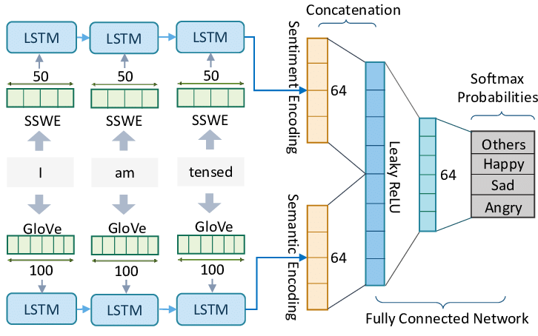**Advantages and Disadvantages**

**Advantages of LSTM and GRU for Sentiment Analysis**

1. Handling Long-Term Dependencies: LSTM and GRU networks can effectively learn and remember long sequences, making them better suited than traditional RNNs for analyzing long texts where context from distant words is important.
2. Gated Mechanisms: Both models use gates to regulate the flow of information, reducing the impact of irrelevant data and enhancing model performance.
3. Efficient Learning: GRUs are computationally lighter than LSTMs due to their simpler structure, often making them faster to train while achieving similar performance.
4. Effective for Sequential Data: These networks are designed to work well with sequential data like text, making them ideal for tasks like sentiment analysis where word order is crucial.

**Disadvantages of LSTM and GRU for Sentiment Analysis**

1. Complexity: LSTMs, in particular, are computationally more complex compared to simpler models like feedforward neural networks. This increases training time and requires more resources.
2. Requires Large Datasets: For LSTM and GRU models to perform well, they often require a large amount of labeled data, which can be a challenge in sentiment analysis tasks with limited annotated datasets.
3. Tuning Hyperparameters: LSTMs and GRUs involve many hyperparameters (e.g., number of layers, hidden units, learning rate) that need to be carefully tuned to achieve optimal performance, making the training process time-consuming.
4. Prone to Overfitting: Both models are highly expressive, which means they can overfit if the dataset is small or not properly regularized (e.g., by using dropout).

**Example Applications of Sentiment Analysis**

* **Social Media Monitoring**: Analyzing user sentiment towards brands, products, or events based on social media posts.
* **Customer Feedback Analysis**: Evaluating product reviews to understand customer satisfaction and areas for improvement.
* **Market Research**: Assessing public opinion on political issues, policies, or market trends based on online discussions.
* **Automated Customer Support**: Classifying and routing customer inquiries based on their sentiment.

**Challenges and Limitations**

1. **Ambiguity in Language**: Sarcasm, irony, and idioms can confuse sentiment classification models.
2. **Data Quality**: Noisy or poorly labeled data can negatively impact model performance.
3. **Domain Specificity**: Models trained on one domain may not generalize well to others without fine-tuning.
4. **Context Understanding**: Capturing long-range dependencies and context can be challenging, even for LSTMs and GRUs.

**Conclusion**

Sentiment analysis using LSTM or GRU networks represents a powerful approach to understanding and interpreting textual data. By leveraging the strengths of these deep learning architectures, it is possible to develop robust models capable of classifying sentiments with high accuracy. Despite the challenges faced in language ambiguity and data quality, sentiment analysis remains an invaluable tool across various industries for gaining insights into public opinion and customer feedback.